CPE 400/600: Computer Communication Networks

NAME:___Patrick Austin___________________________________ CPE400/600: 400

**HW 2**

**Part 1**

1. TCP uses a 3-way connection establishment protocol rather than a 2-way protocol in order to reduce the possibility of handshake failure owing to the Two Generals Problem. A 2-way handshake can enter an infinite loop of waiting for ACKs of ACKs, as with the generals in the problem waiting for confirmation of confirmation of the time of attack, ad infinitum. TCP’s approach, the SYN/SYNACK/ACK 3-way handshake, is less prone to this type of failure.

2. The information for the packet traveling from Host B to Host A will be the following:

Source port: y

Destination port: x

Seq no.: 426

Ack no.: 261

3. See next page for X-Y plot showing how these values were found.

* 1. Before the 8th transmission starts, the CWND = 33 and the ssthreshold = 32.
  2. Before the 11th transmission starts, the CWND = 4 and the ssthreshold = 16.
  3. After the 12th transmission, the CWND = 3 and the ssthreshold = 2.

**Part 2**

4.

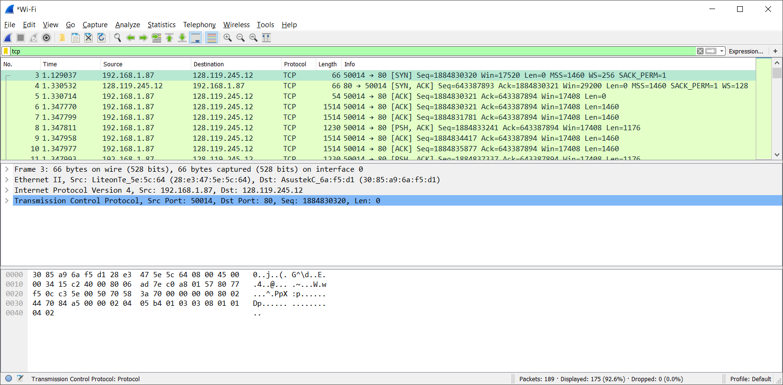

The IP address used by gaia.cs.umass.edu is 128.119.245.12, as shown in the destination field of the highlighted packet. The packet also shows that the TCP port number used by my computer, the source port, is 50014.

5.

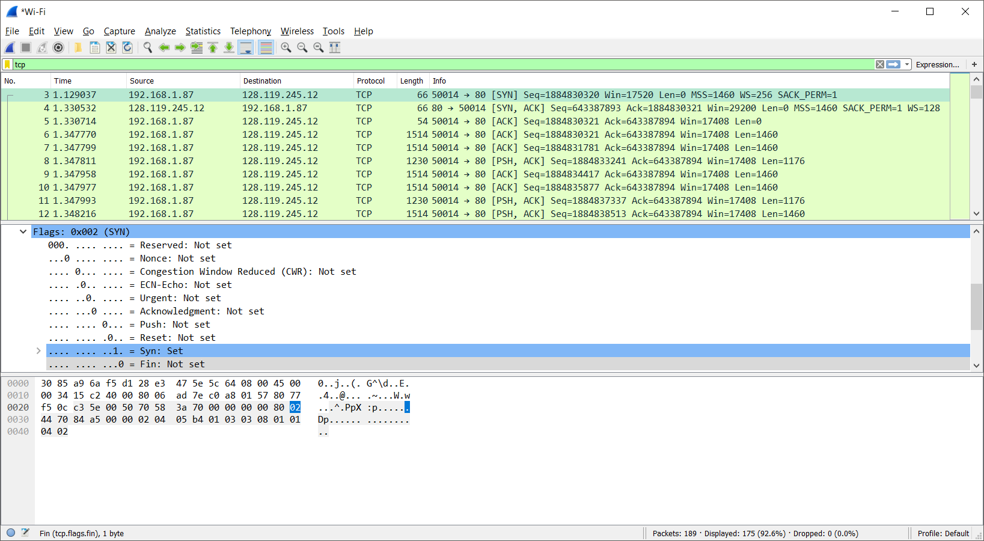

The actual sequence number is 1884830320 and the relative sequence number is 0 for the TCP SYN segment. The actual sequence number is displayed in the highlighted packet, and the relative sequence number can be determined by this packet being the initial packet in the communication from the client’s point of view. The component of the segment that identifies it as the SYN segment is the SYN flag, which is raised, as is shown in the screenshot.

6.

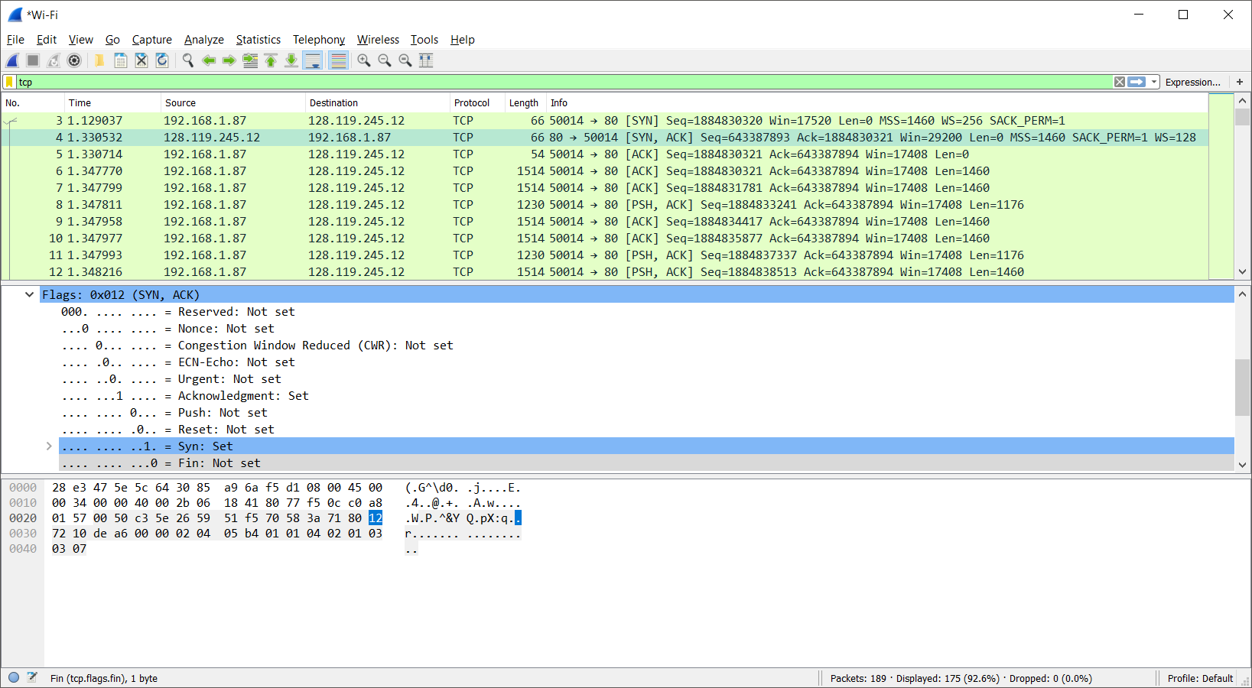

The actual sequence number is 1884830320 and the relative sequence number is 0 for the TCP SYNACK segment. The actual sequence number is displayed in the highlighted packet, and the relative sequence number can be determined by this packet being the initial packet in the communication from the server’s point of view. The component of the segment that identifies it as the SYNACK segment are the SYN and ACK flags, which are both raised, as is shown in the screenshot.

**Part 2: TCP Congestion Control**

7.

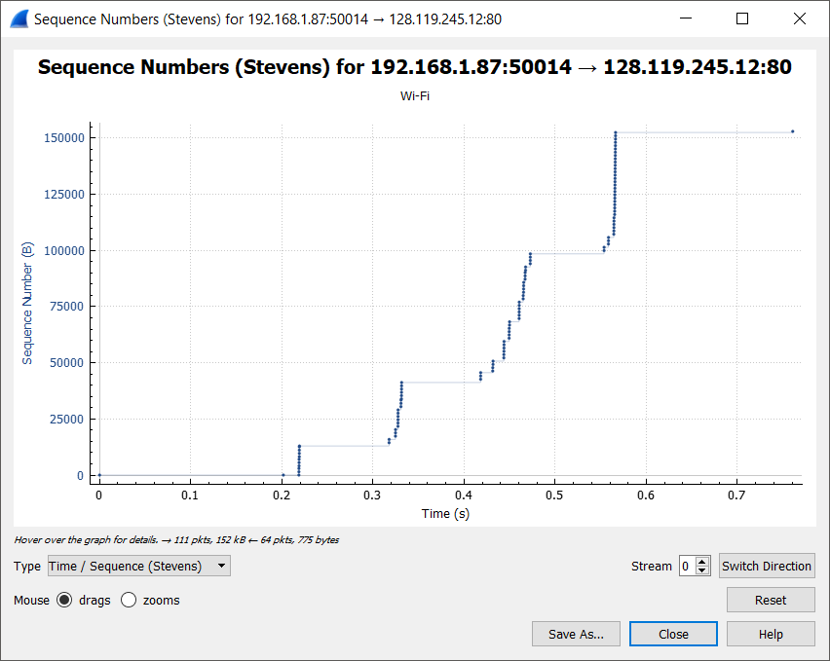

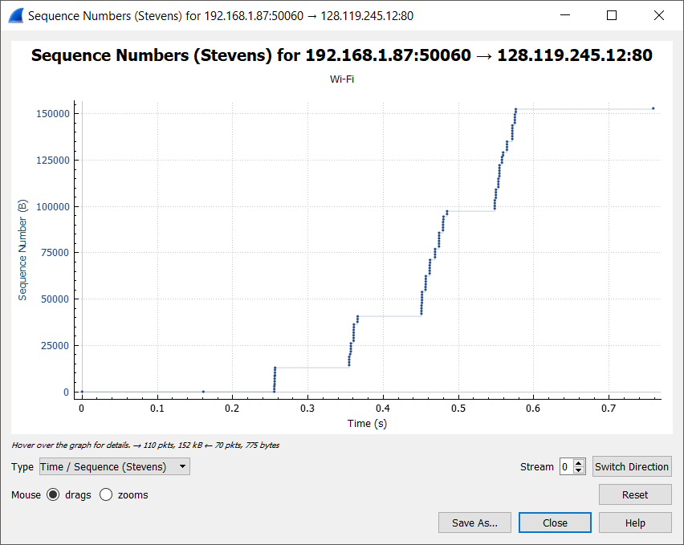

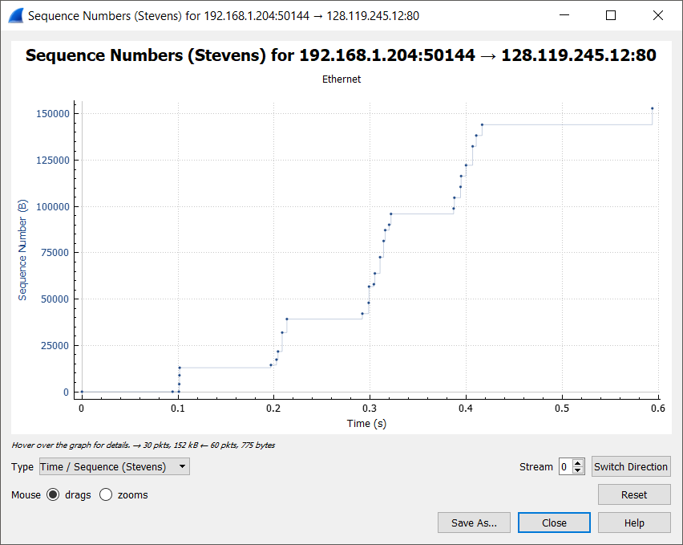

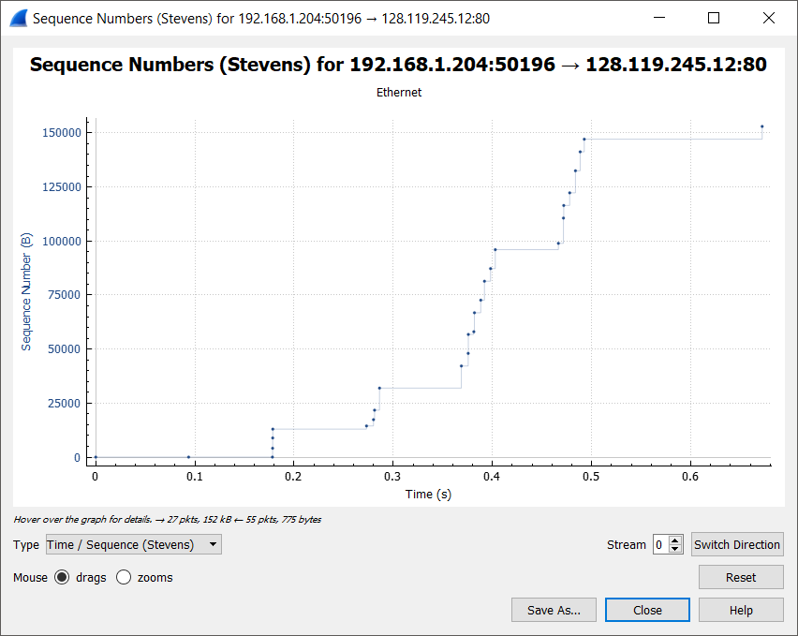

The first two screenshots show tests at approximately 10PM, the third shows a test at approximately 8AM, and the fourth shows a test at approximately 12PM. The first two tests were conducted via wifi and the third and fourth were conducted via Ethernet. Though the wifi tests used more packets, the behavior was generally similar. Slow start appears to take place during the first 2 “bursts” of packet transmission that can be seen on the graphs, ending somewhere between .2 and .4 seconds into the transmission depending on the test round. That said, the slow start behavior shown does not adhere to the 1-2-4-8 exponential behavior we expected. As shown above, in the final test, the bursts consist of 1-4-4-9-7 packets.

8. For one thing, the very short duration of these transmissions makes it difficult to compare the packet behavior to the idealized, orderly version learned about in this class. In general, the 4-bursts-of-packets behavior displayed by my connection leads to a lack of information, which makes it difficult to verify exactly where the slow start phase ends, where the linear increase phase begins, and what the rate of linear increase is. The final burst may be being “cut off” due to the transmission being complete, making the pattern harder to see as well. It’s possible that real world practicalities, such as the size of the file transmission being fairly small, or the setup of the destination server, are truncating or modifying the idealized TCP behavior as well.